

Dim Light Melatonin Onset Test Information

Thank you for participating in our research study. This information sheet will give you full details of how to collect saliva samples. We will use these saliva samples to investigate changes in a hormone associated with night time (melatonin) in your saliva. Melatonin is a brain hormone released from the pineal gland at the back of the brain into the blood (and saliva) in order to signal that it is night time.

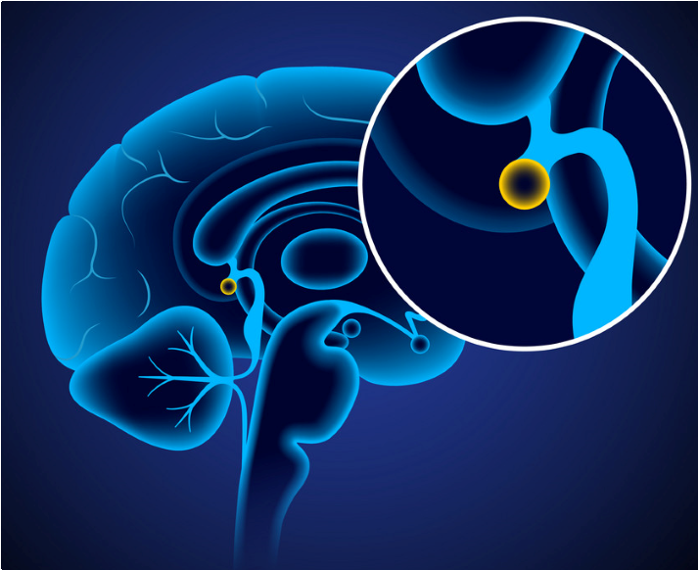

Pineal Gland

**Light**

**Melatonin**

**in Saliva**

**Dark**

What is in the test kit?

You will be given one test kit that will contain the following:

16 sample tubes

Freezer box

Sample recording chart

Night light

Light meter

What you need to do

1. Start the study 6 hours before your usual bedtime. So, for example, if usual bedtime is 11pm then start sampling at 5pm.
2. Please dim the lights or use the night light that we will provide. Please be cautious when moving around the room in dim light. The lights in your bedroom must be dimmed, as must be the corridor and bathroom light.
3. Please do not use screens during the sample taking. Reading is allowed but may be difficult in dim light. If this is a problem we will supply you with a book light that you can use, and we will show you how to use it without exposing yourself to too much light.
4. You will need to wear a light meter around your neck throughout the test so that we can check if you have been exposed to too much light.
5. Please do not eat or drink or brush your teeth 20 minutes before each sample; this includes water.
6. Collect saliva samples by spitting into the sample tube. We need about half a ml – this is indicated by the line on the tube.
7. Collect samples every 30 mins for 6 hours before your usual bedtime and for two hours after your usual bedtime. You must stay awake for all samples, even those collected after usual bedtime.
8. Please store the samples in the freezer box overnight, until a researcher calls to collect them in the morning.

Please be careful to remain in dim light throughout the test. Even a few minutes of bright light will suppress your melatonin production and invalidate the test. We will be able to tell from your light meter if you have been exposed to bright light at any stage during the DLMO. If this happens then the test have to be repeated or you will need to withdraw from the study.

If you have any problems or questions during the test you can always contact the research team: AmbientBD@mu.ie (mailto:AmbientBD@mu.ie)

#### Thank you very much for your support with our research